hgj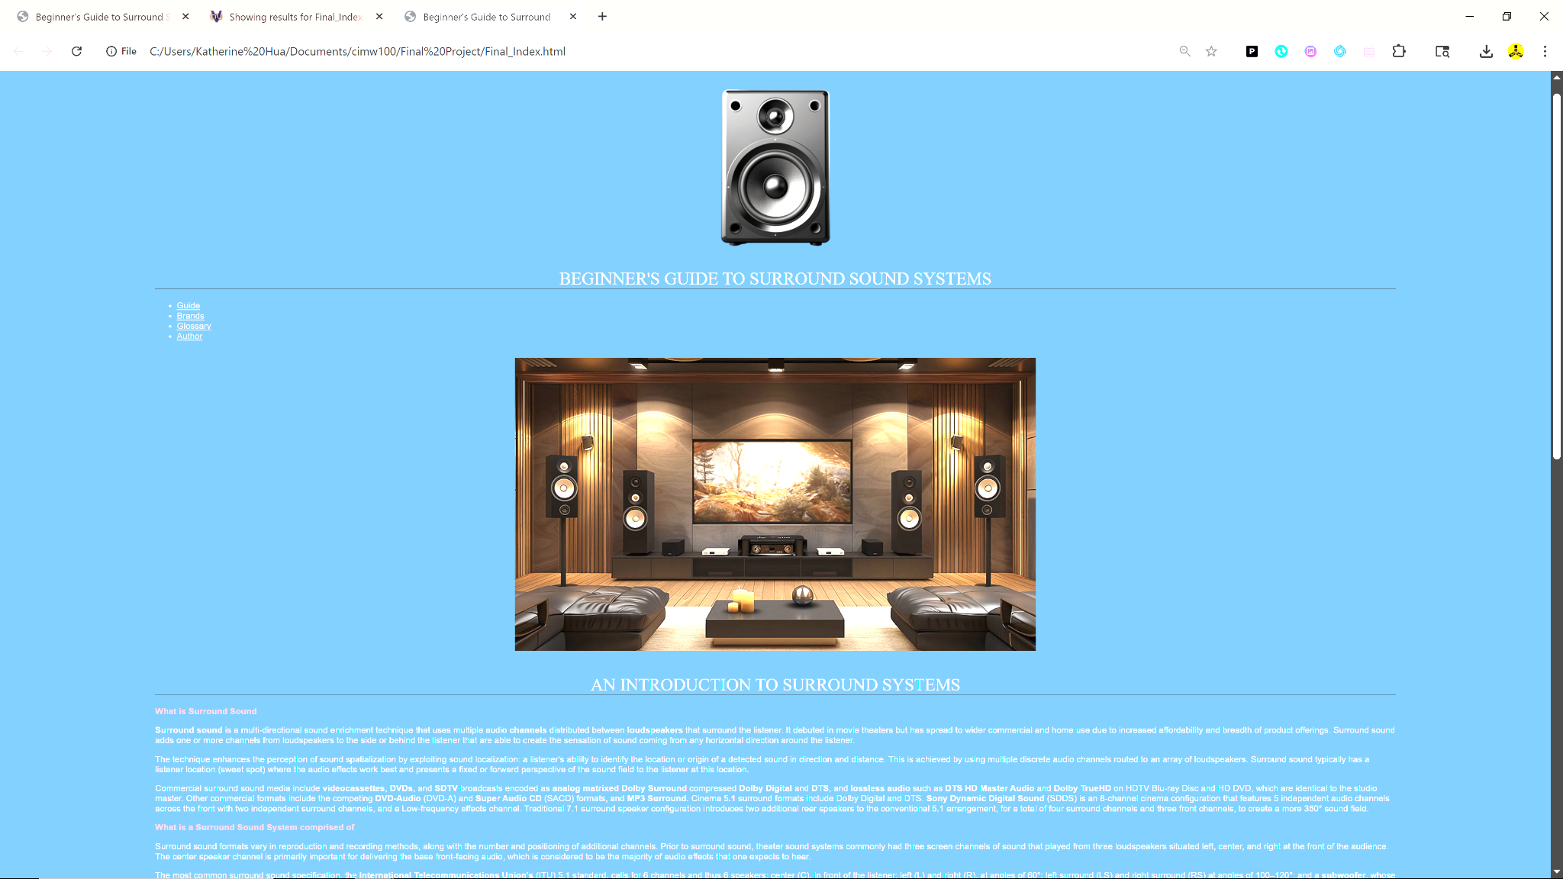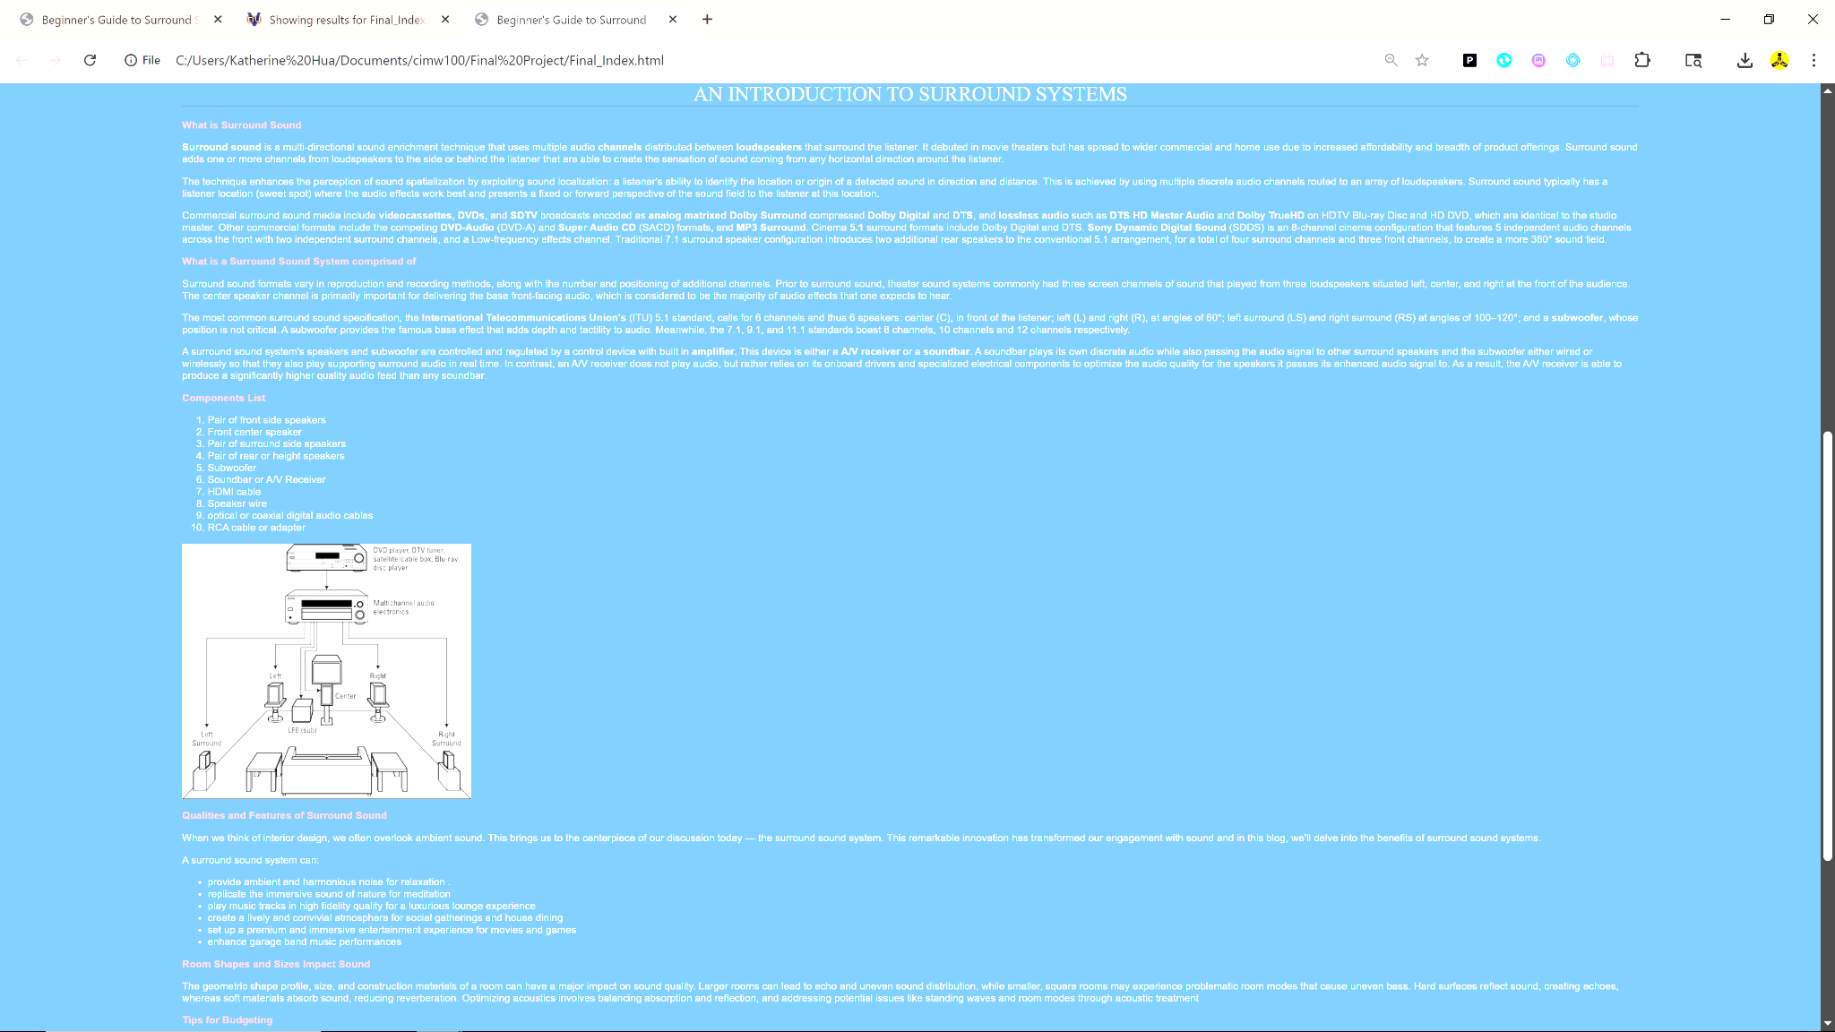
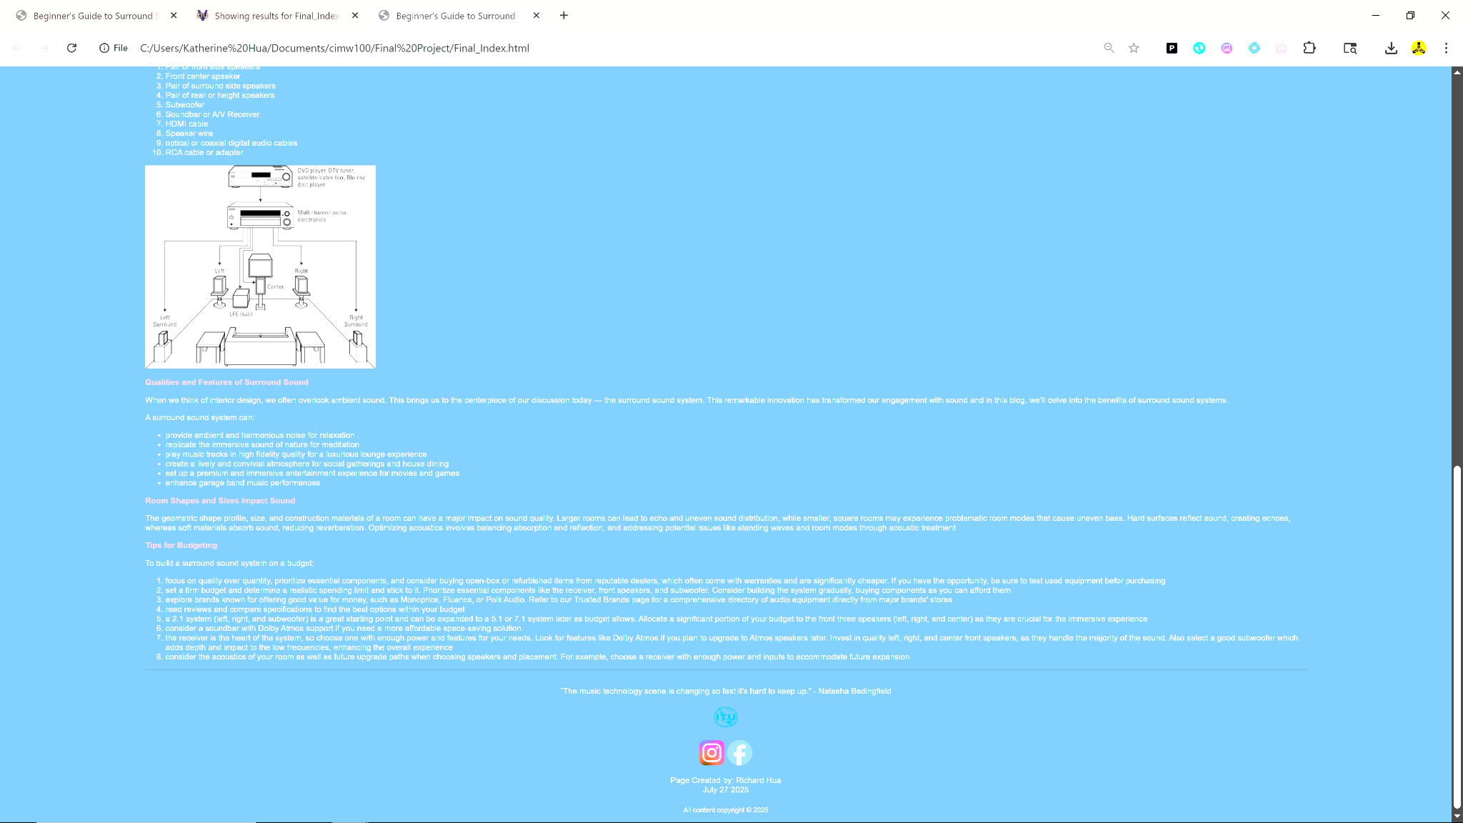
Unordered and ordered lists
Descriptive list of terms
Headers 1 and 2 (Center White and Red)
Meta formatting in top
External links to ITU organization site and two social media links to personal profile at bottom
Copyright and date stamped at bottom
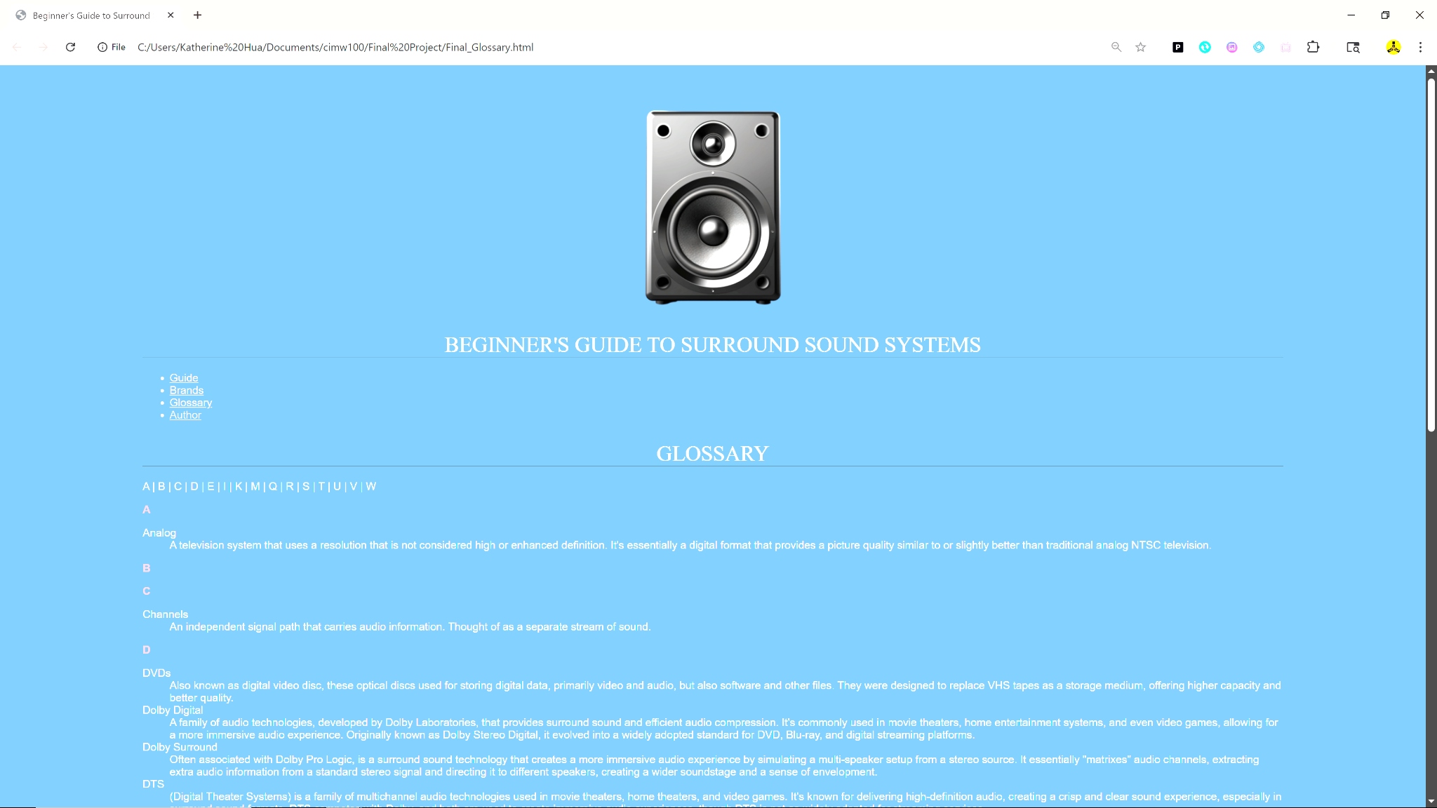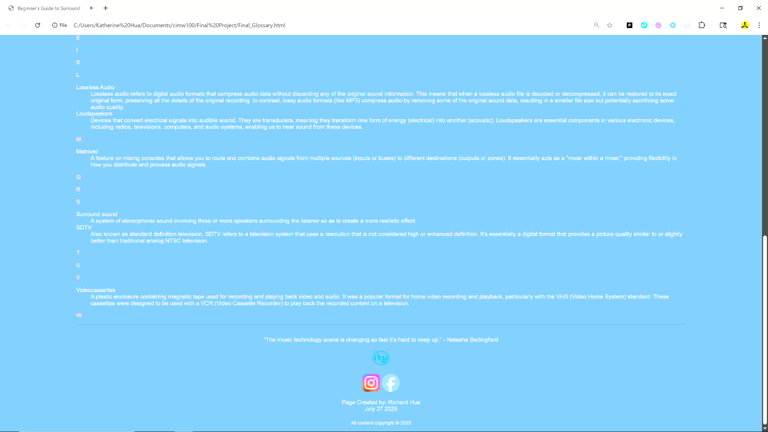

Descriptive list of terms
Headers 1 and 2 (Center White and Red)
Meta formatting in top
External links to ITU organization site and two social media links to personal profile at bottom
Copyright and date stamped at bottom

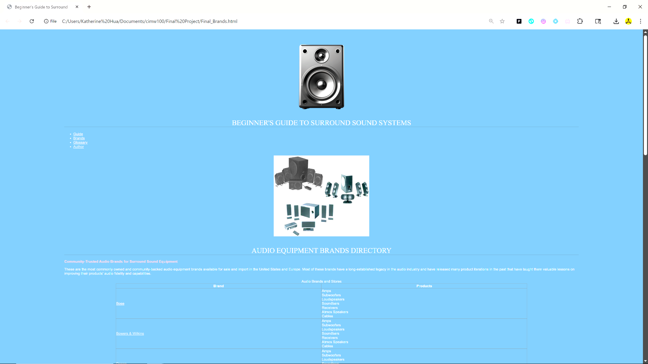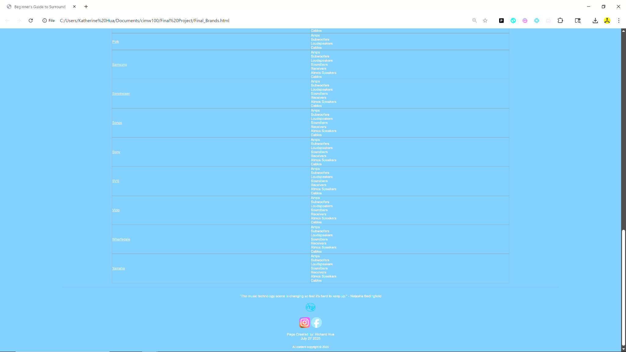

Hyperlinks to external sites
Table
Headers 1 and 2 (Center and Red)
Meta formatting in top
External links to ITU organization site and two social media links to personal profile at bottom
Copyright and date stamped at bottom

