hgj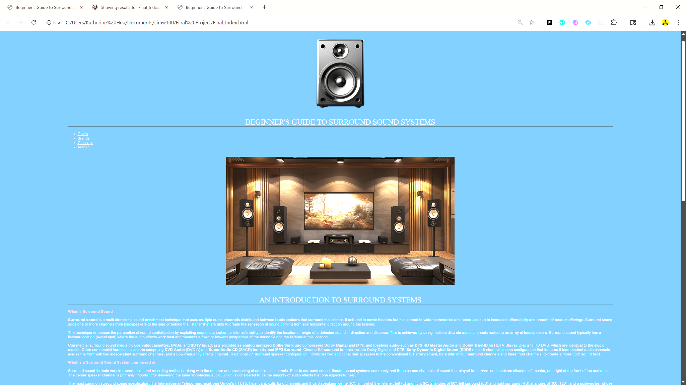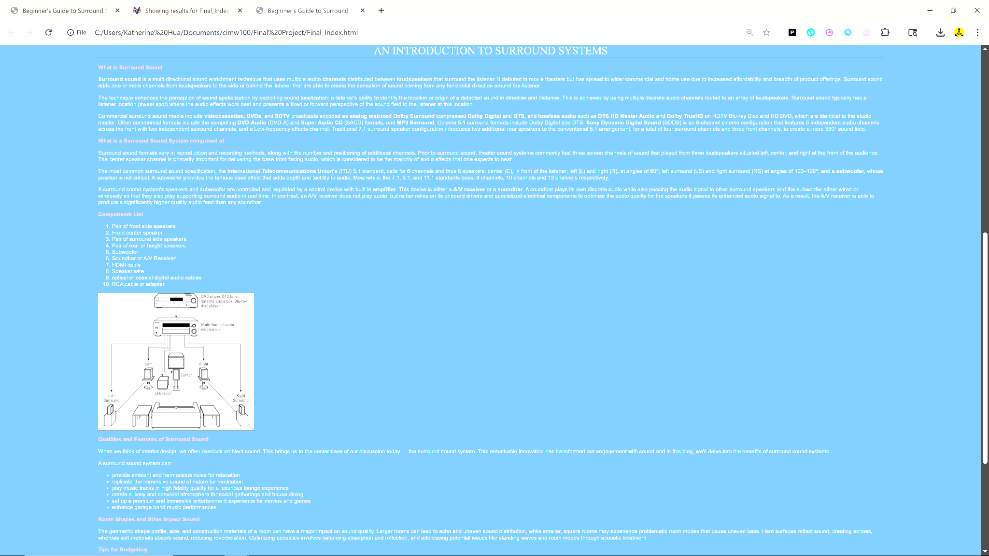
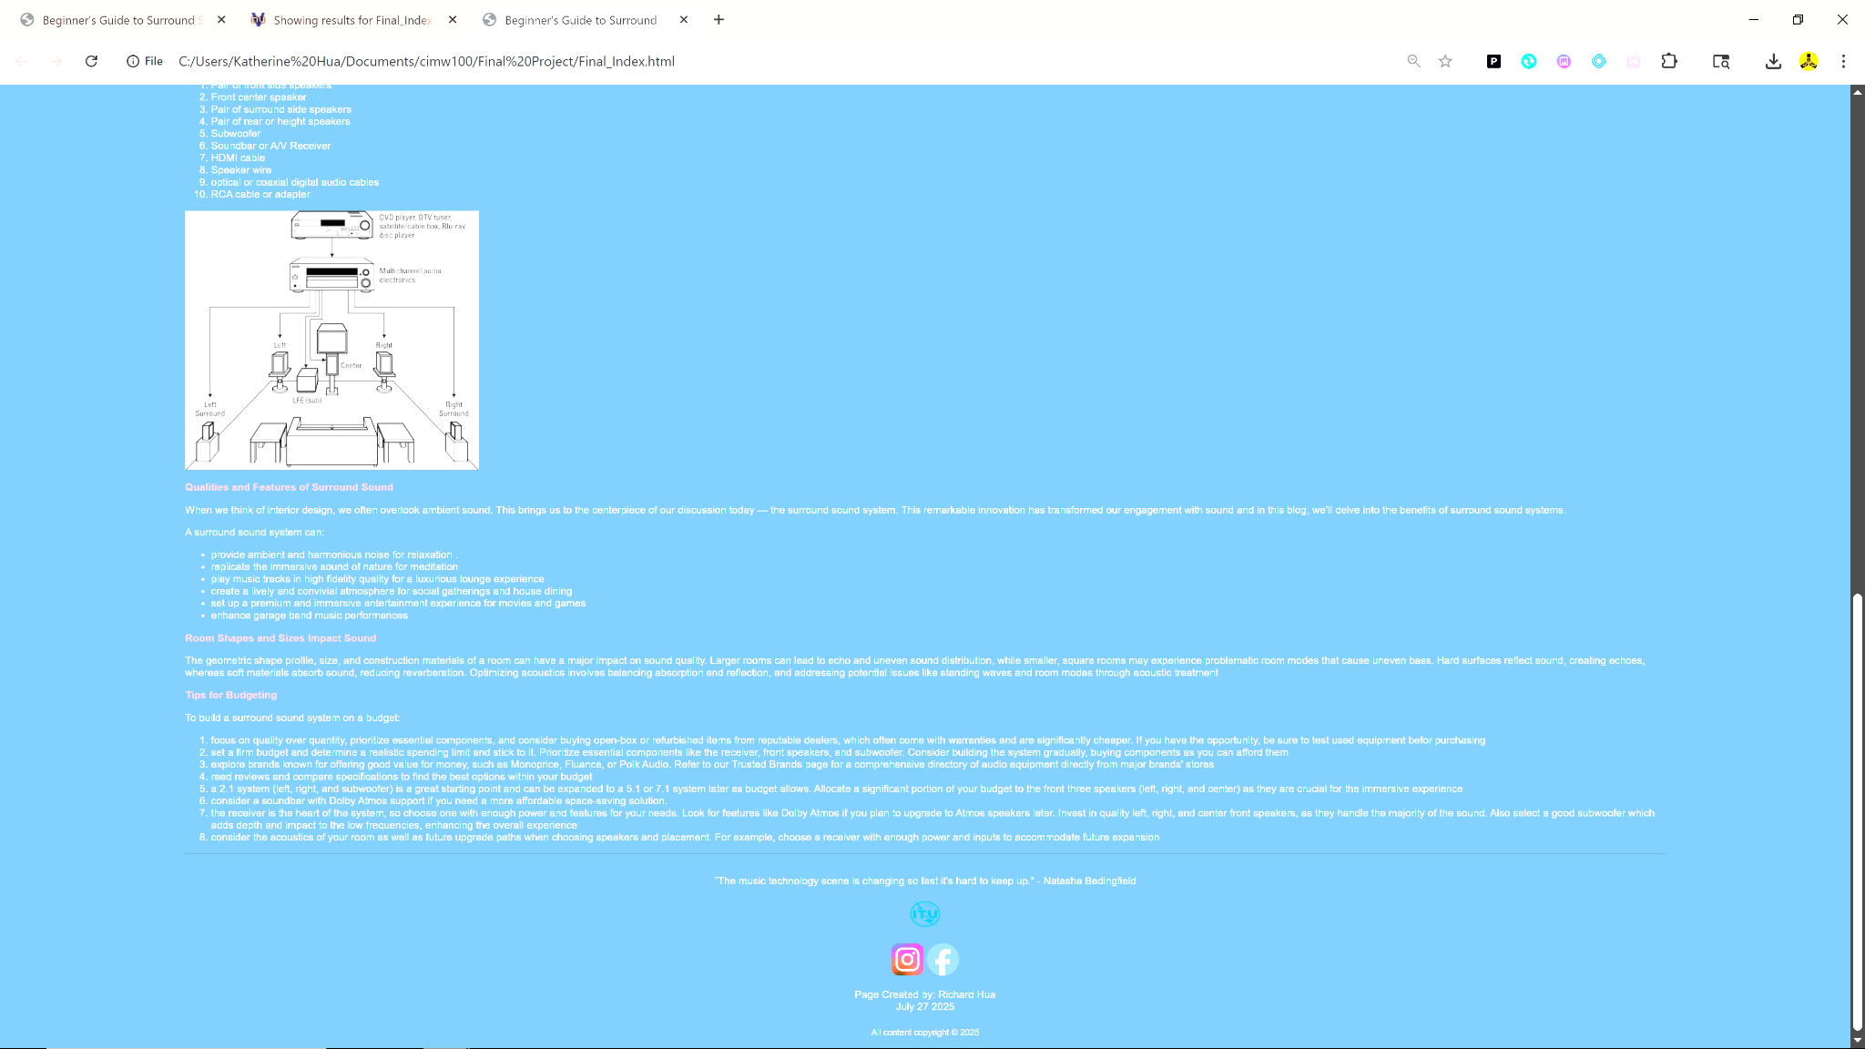
Unordered and ordered lists
Descriptive list of terms
Headers 1 and 2 (Center White and Red)
Meta formatting in top
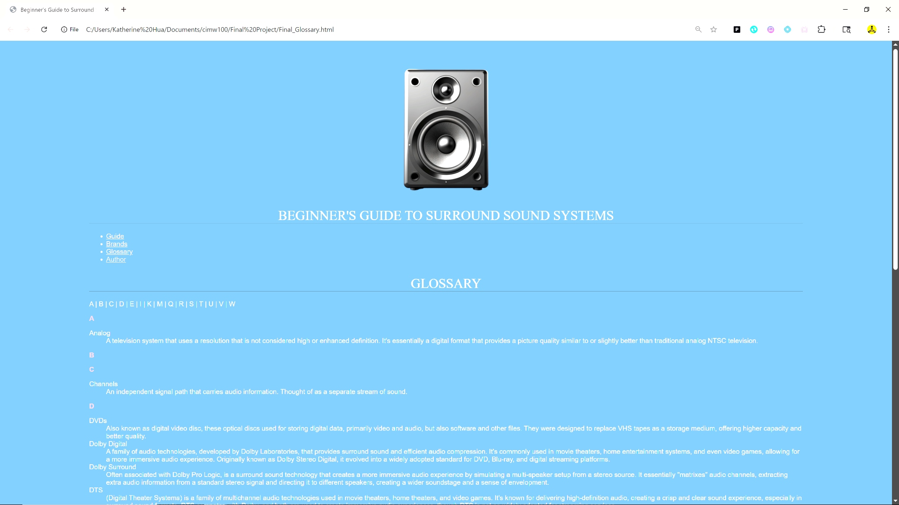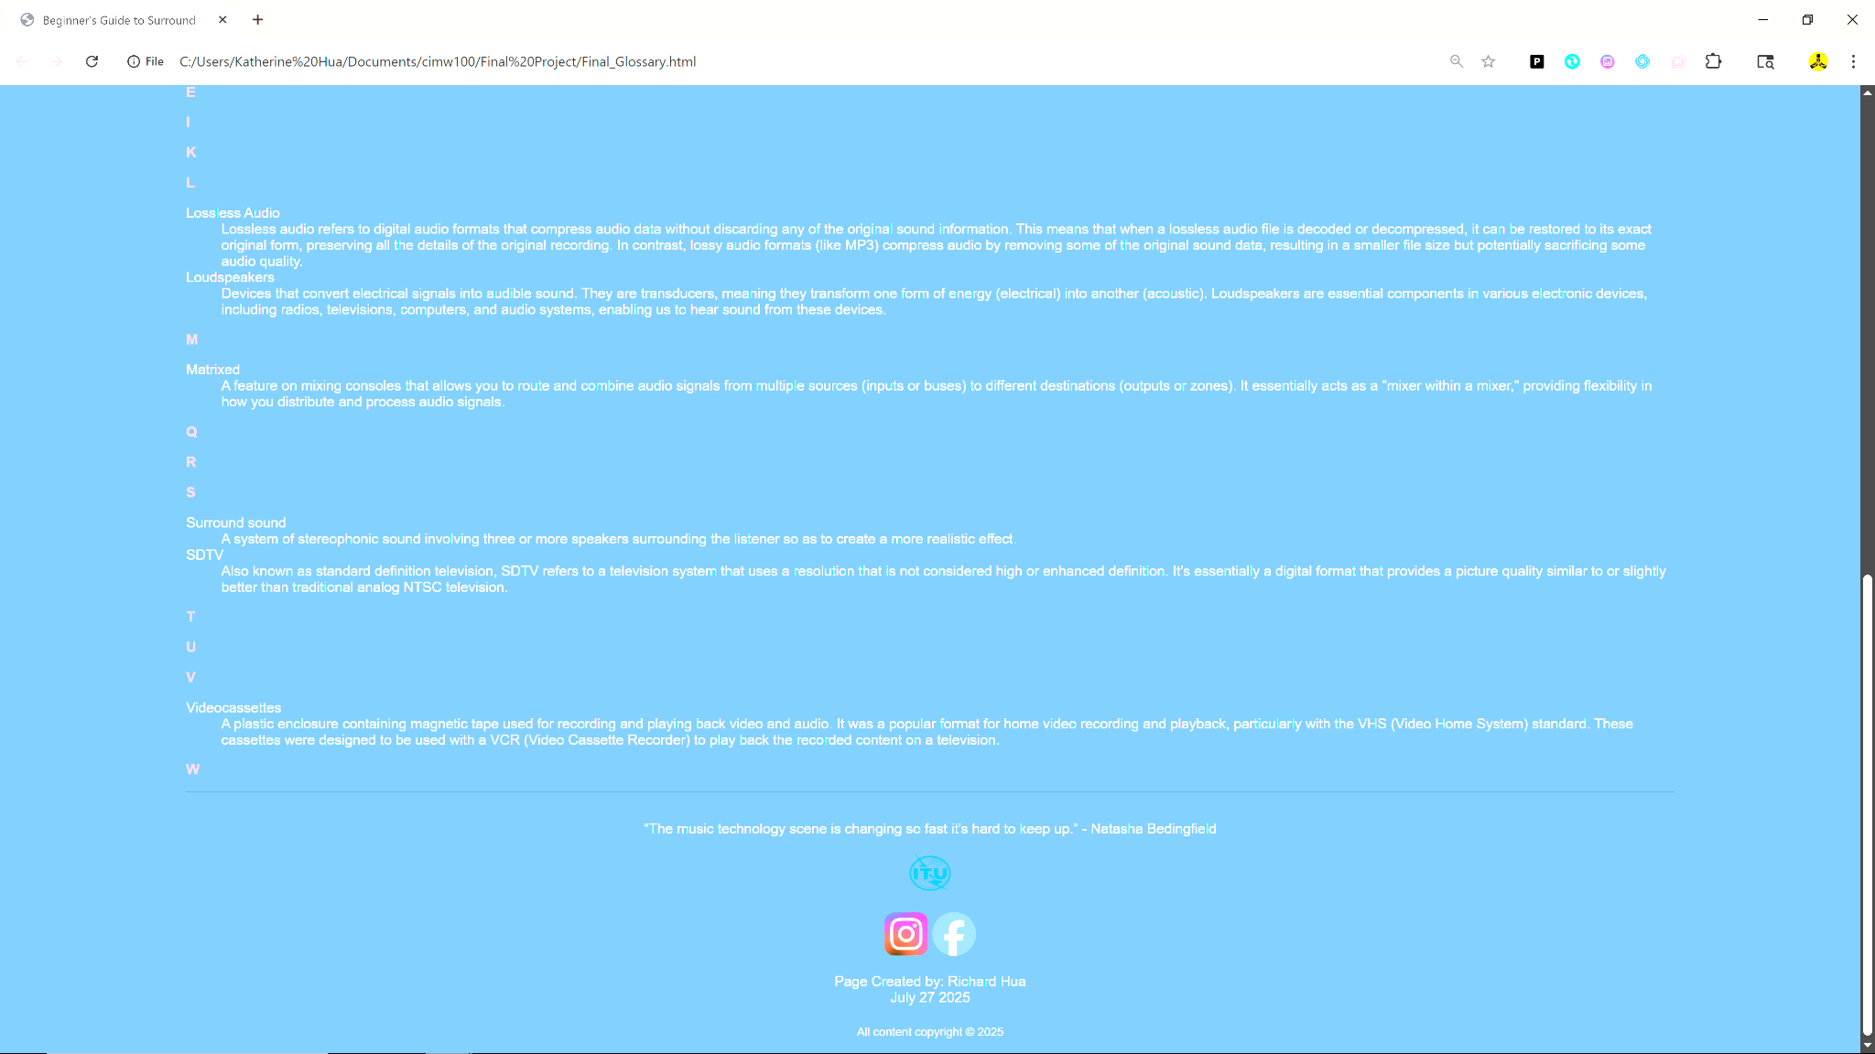

Descriptive list of terms
Headers 1 and 2 (Center White and Red)
Meta formatting in top

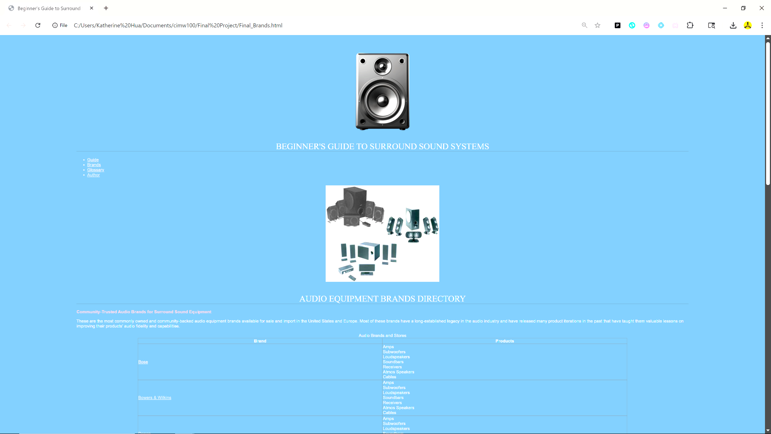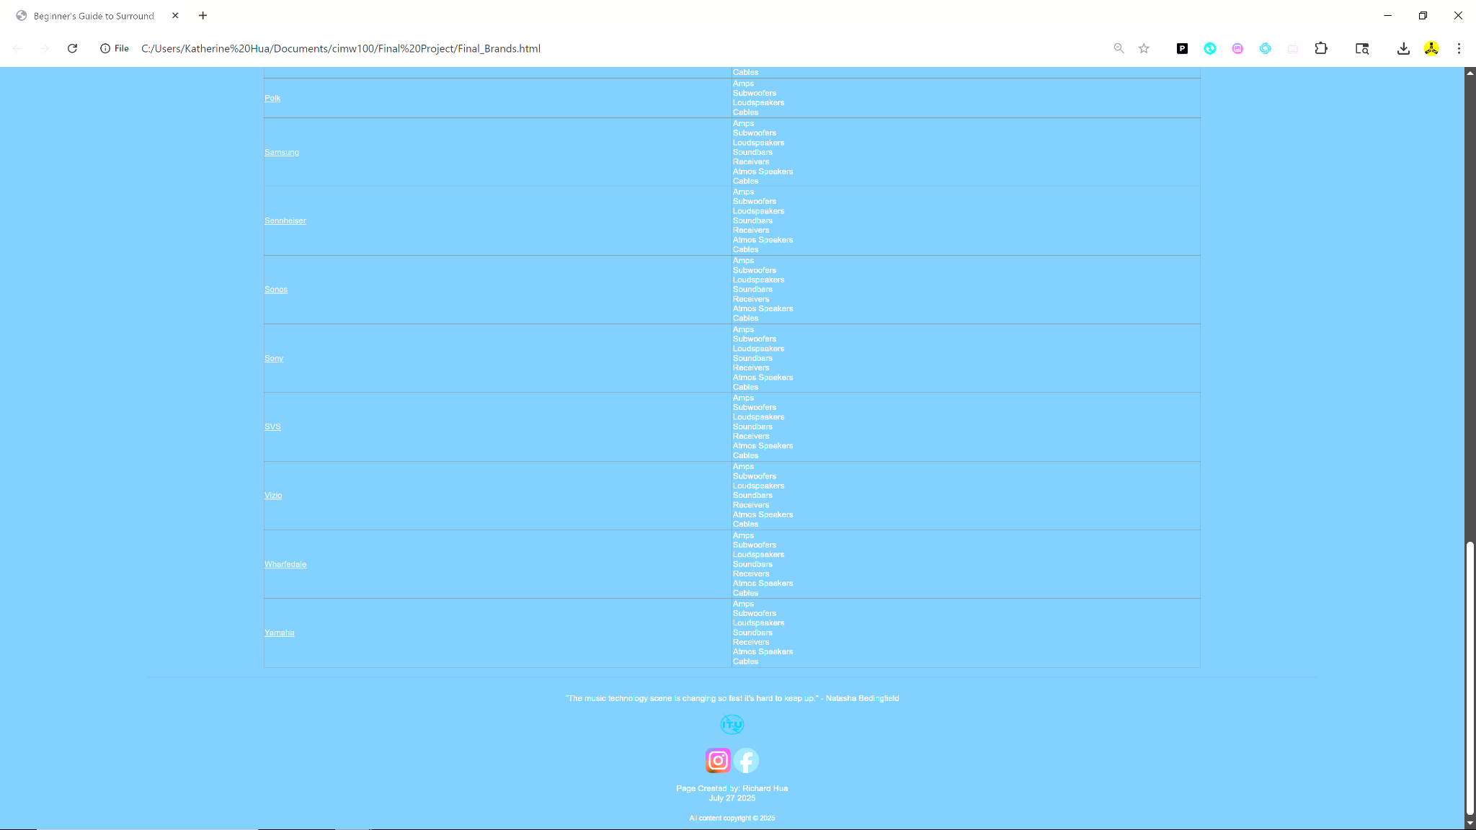

Hyperlinks to external sites
Table
Headers 1 and 2 (Center and Red)
Meta formatting in top

