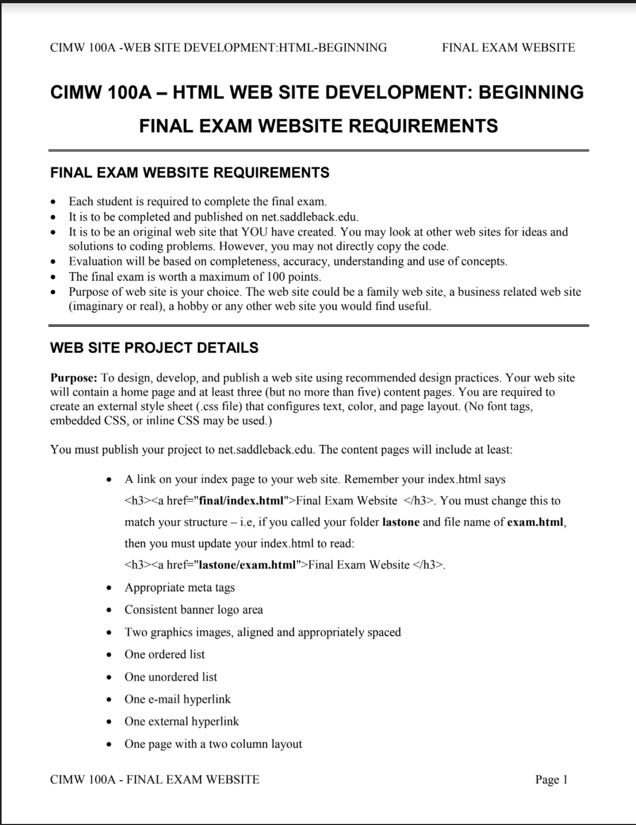
CIMW 100A -WEB SITE DEVELOPMENT:HTML-BEGINNING FINAL EXAM WEBSITE

CIMW 100A - FINAL EXAM WEBSITE Page 1
CIMW 100A – HTML WEB SITE DEVELOPMENT: BEGINNING

FINAL EXAM WEBSITE REQUIREMENTS

FINAL EXAM WEBSITE REQUIREMENTS
• Each student is required to complete the final exam.
• It is to be completed and published on net.saddleback.edu.
• It is to be an original web site that YOU have created. You may look at other web sites for ideas and
solutions to coding problems. However, you may not directly copy the code.
• Evaluation will be based on completeness, accuracy, understanding and use of concepts.
• The final exam is worth a maximum of 100 points.
• Purpose of web site is your choice. The web site could be a family web site, a business related web site
(imaginary or real), a hobby or any other web site you would find useful.

WEB SITE PROJECT DETAILS
Purpose: To design, develop, and publish a web site using recommended design practices. Your web site
will contain a home page and at least three (but no more than five) content pages. You are required to
create an external style sheet (.css file) that configures text, color, and page layout. (No font tags,
embedded CSS, or inline CSS may be used.)
You must publish your project to net.saddleback.edu. The content pages will include at least:
• A link on your index page to your web site. Remember your index.html says
<h3><a href="final/index.html">Final Exam Website </h3>. You must change this to
match your structure – i.e, if you called your folder lastone and file name of exam.html,
then you must update your index.html to read:
<h3><a href="lastone/exam.html">Final Exam Website </h3>.
• Appropriate meta tags
• Consistent banner logo area
• Two graphics images, aligned and appropriately spaced
• One ordered list
• One unordered list
• One e-mail hyperlink
• One external hyperlink
• One page with a two column layout

